**DNS Server Configuration**

At Server Side:

1. Install DNS server packages as shown below-



2. Set the fully qualified domain name-



3. Verify it using hostnamectl command-



4. Start & enable dns service named-



5. Check the service status-

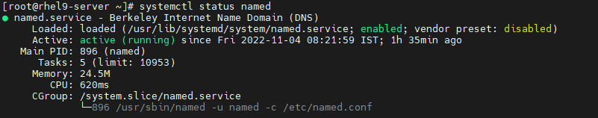

6. Take backup of /etc/named.conf file as shown below-



7. Now edit named.conf file as shown-

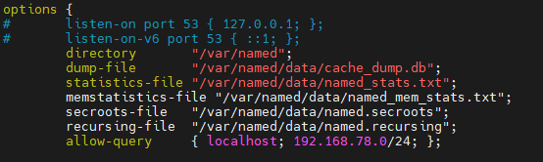

We have to comment 2nd & 3rd line and add our network in allow-query in last line in above pic. Now go to last section of this file & created forward & reverse lookup zone & save the file as shown below-

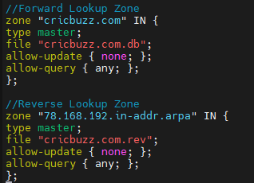

8. Now, we will create forward DNS zone file, cricbuzz.com.db (Mentioned in named.conf file) in /var/named directory & add lines shown below–

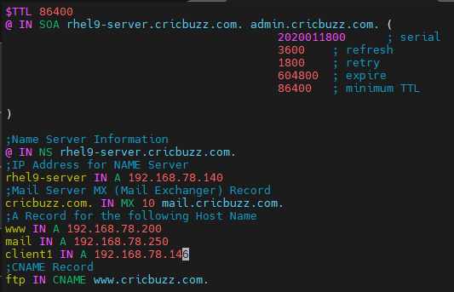

Here, 192.168.78.146 is one of client’s IP.

9. In the same way, we will create reverse DNS zone file, cricbuzz.com.rev (Mentioned in named.conf file) in /var/named directory & add lines shown below–

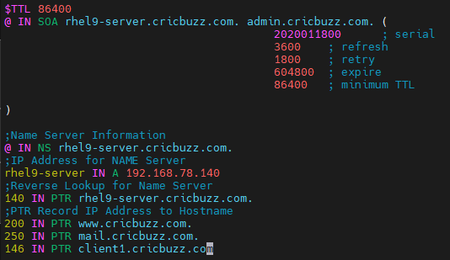

10. Now, changed the ownership of these two files to named as shown below-

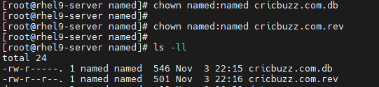

11. Now check the configuration using below commands-

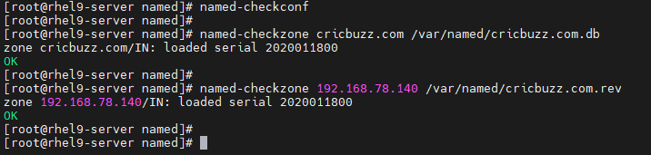

Here, 192.168.78.140 is DNS server IP.

12. Add DNS service in firewall to allow-

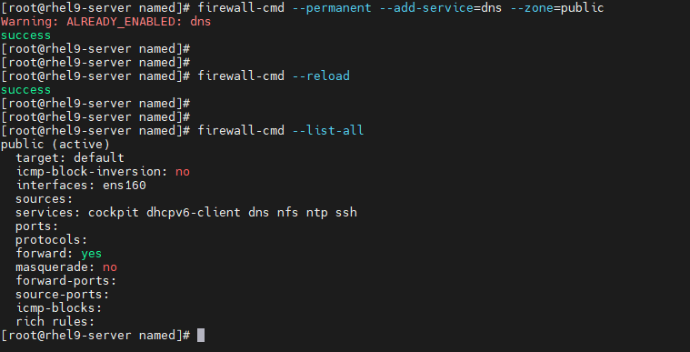

At Client Side:

1. Add DNS server IP in /etc/resolv.conf-

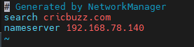

Or, we can add nameserver using nmtui command (To edit connection)-

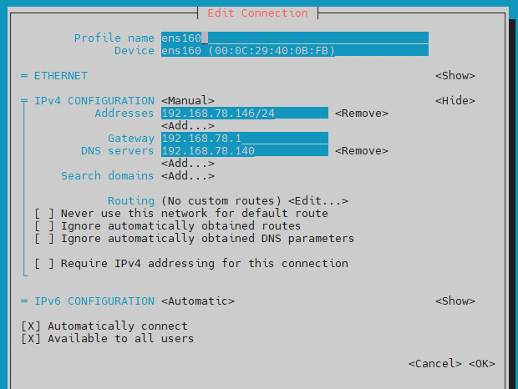

2. Now restart NetworkManager-



3. To verify, we will use nslookup at client side as shown below-

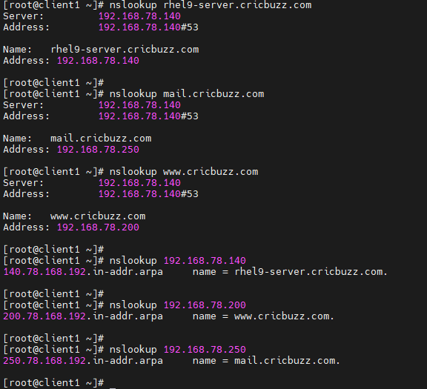

4. To verify client DNS, we will use nslookup at Server side as shown below-

